Daily Stretch Routine A (w/clockwise jog)

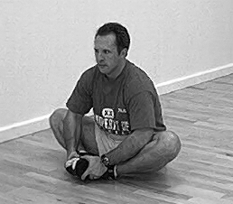Inner Thigh *(Groin Stretch)
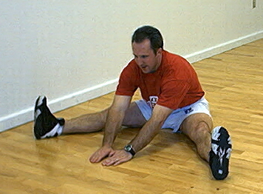Hamstring Type One
Latissimus Dorsi *(Back muscle)

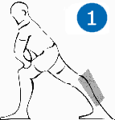Gastrocnemius *(Calf muscle)

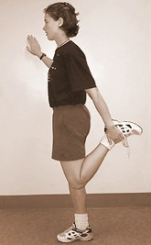Quadriceps

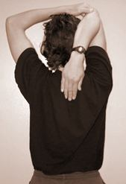Triceps

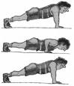 Push Ups = 10

